**Reactjs**

React is a **JavaScript library** for building **fast, interactive, and reusable UI components**. It is maintained by **Meta (Facebook)** and widely used for developing modern web applications.

**Why Use React?**

• **Component-Based Architecture** – Helps in building reusable UI components, making development efficient.

• **Virtual DOM** – Improves performance by updating only the necessary parts of the actual DOM.

• **Fast & Scalable** – React efficiently handles large-scale applications with dynamic data.

• **Strong Community & Ecosystem** – Large community support with extensive third-party libraries.

• **Easy to Learn & Use** – Uses JSX (JavaScript XML) for a simple and declarative UI-building experience.

**Components, Props, and JSX in React**

**1.Components**

• The building blocks of a React application.

• Can be **functional** or **class-based**.

• Reusable and independent UI elements.

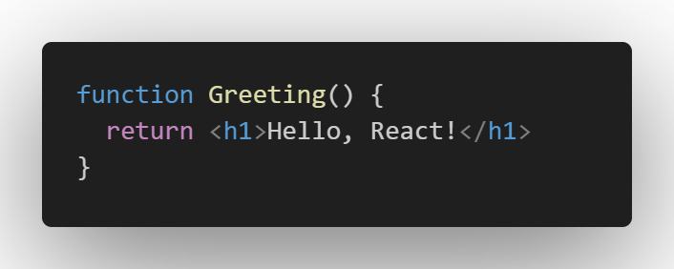

**2. Props (Properties)**

* Used to **pass data** from a parent component to a child component.
* **Immutable** (cannot be modified inside the child component).

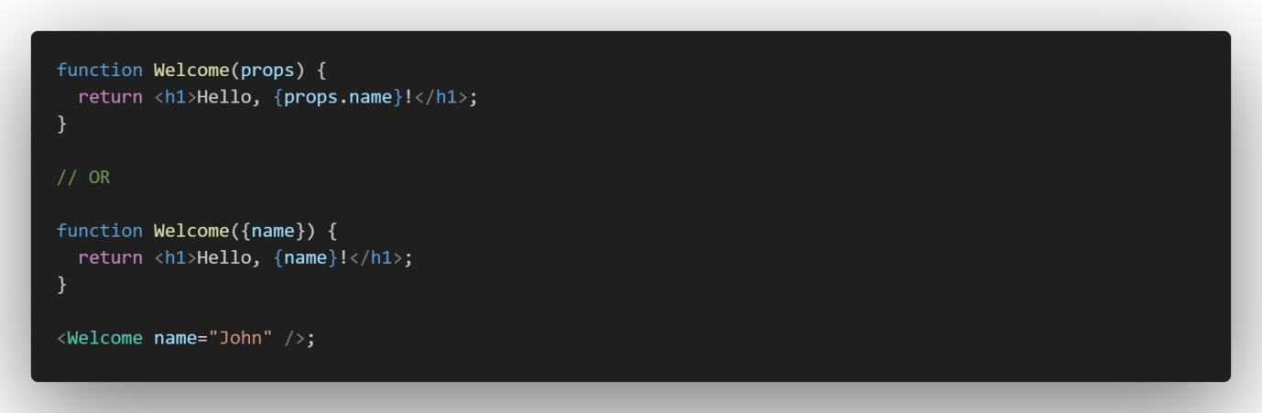

**3. JSX (JavaScript XML)**

• A **syntax extension** of JavaScript used in React.

• Allows writing HTML inside JavaScript.

• Makes UI code more readable and easier to maintain.

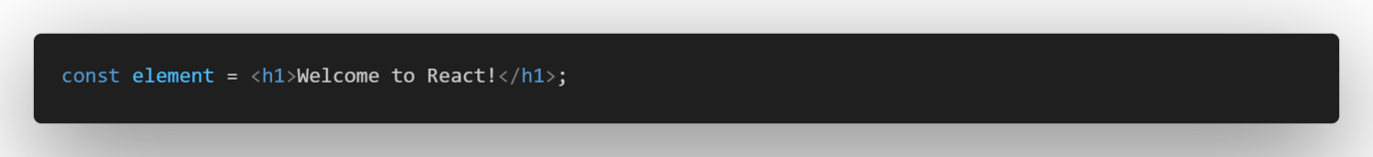

**Hooks & State in React**

**Hooks**

Special functions that let you use React features inside functional components.

Common hooks:

* **useState** → Manages state.
* **useEffect** → Handles side effects.
* **useContext** → Accesses global state.

**State**

• State stores dynamic data and updates trigger re-renders.

• Managed using the **useState** hook.

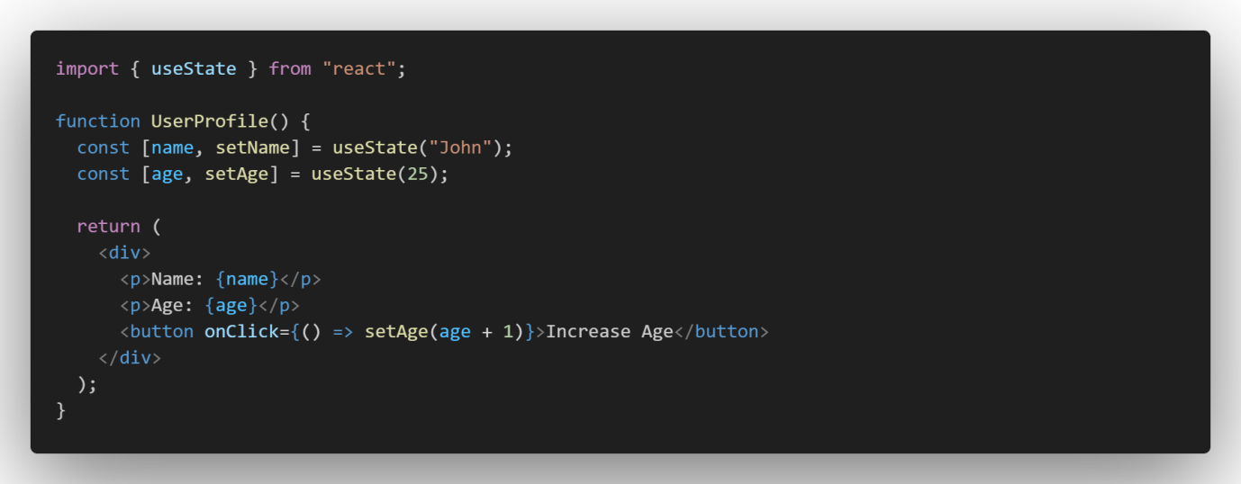

**useEffect Hook in React**

A React **hook** that performs **side effects** in functional components.

Used for:

* Fetching data (API calls)
* Subscriptions (e.g., WebSockets)
* DOM updates
* Cleanup operations

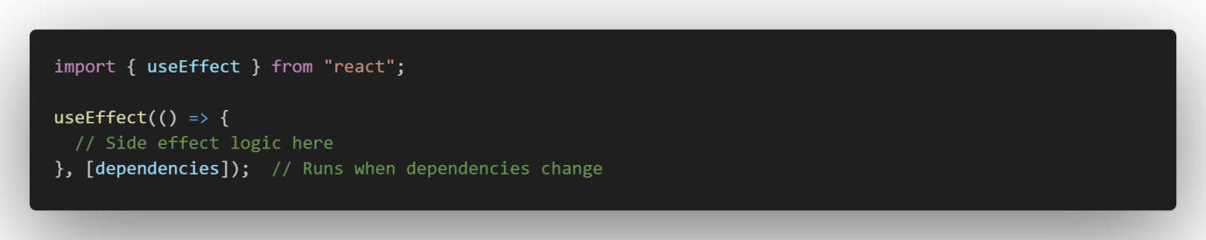

a) Run useEffect on Every Render (Runs after every render)

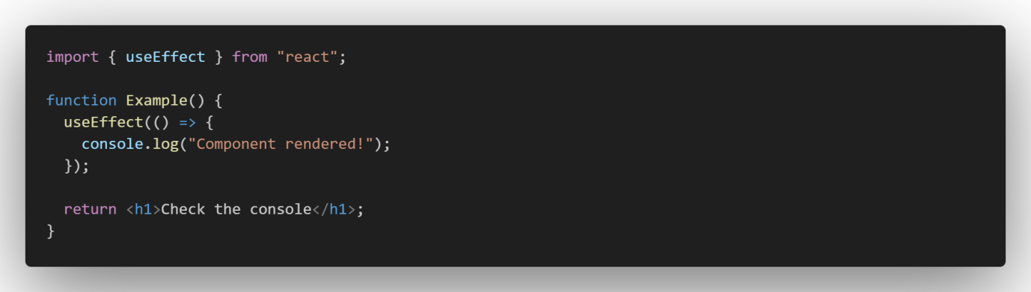

b) Run useEffect Only on Mount (Empty Dependency Array [])(Runs only once when the component mounts.)

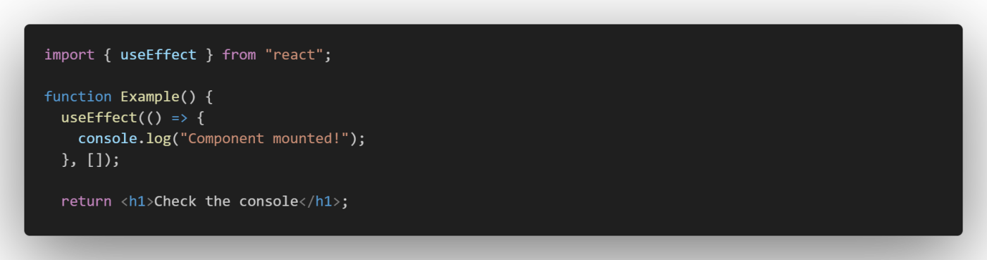

c) Run useEffect When a Specific State Changes (Runs whenever count changes.)

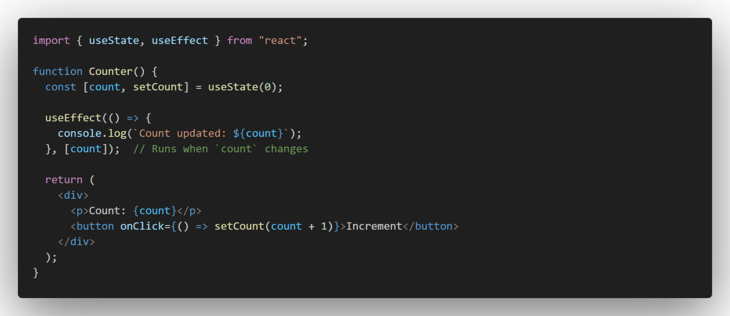

d) Cleanup in useEffect (e.g., Unsubscribe Events) (Cleans up event listeners when the component unmounts.)

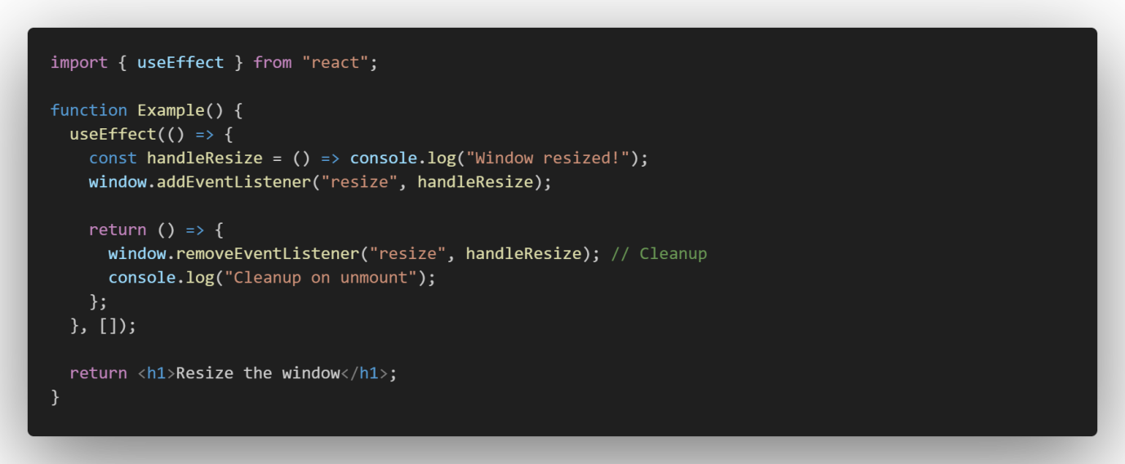

**useEffect helps manage side effects in React functional components efficiently!**

**useRef Hook in React**

• A React **hook** that creates a **mutable reference** to store values **without causing re-renders**.

• Common use cases:

* **Accessing DOM elements** (e.g., focus an input).
* **Storing previous values** without re-rendering.
* **Persisting values between renders** without triggering updates.

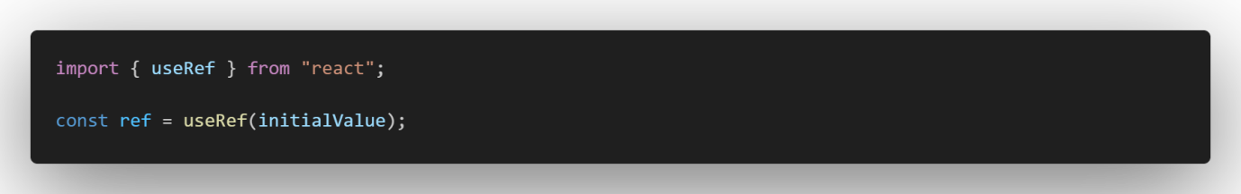

**a) Accessing DOM Elements** (The button clicks will focus on the input field.)

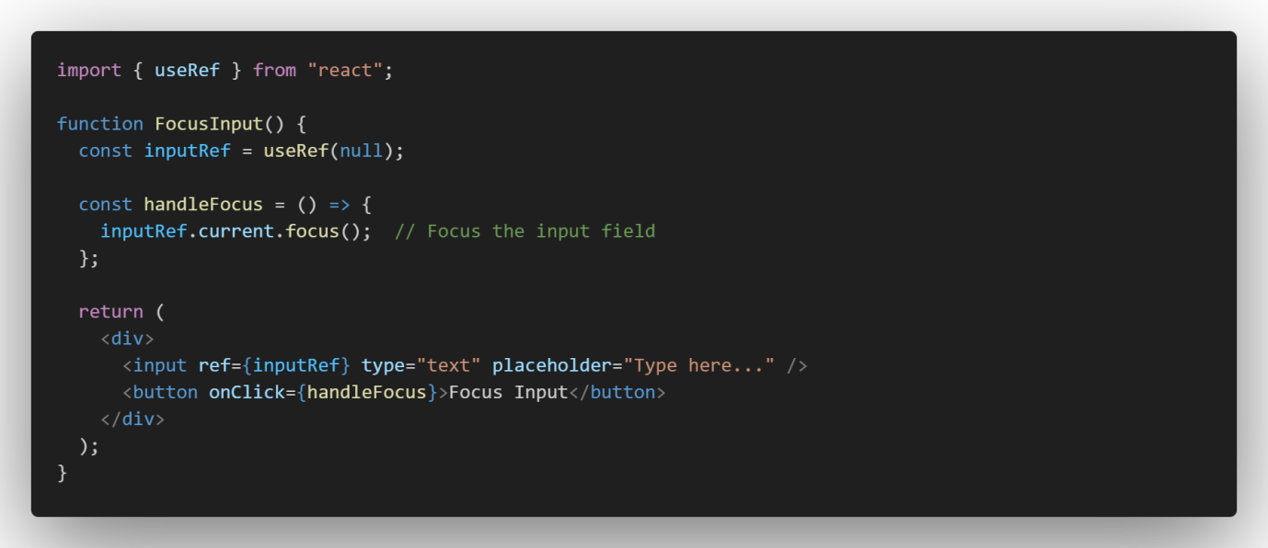

**b) Storing Previous State without Re-Rendering** (Stores the previous count value without causing re-renders.)

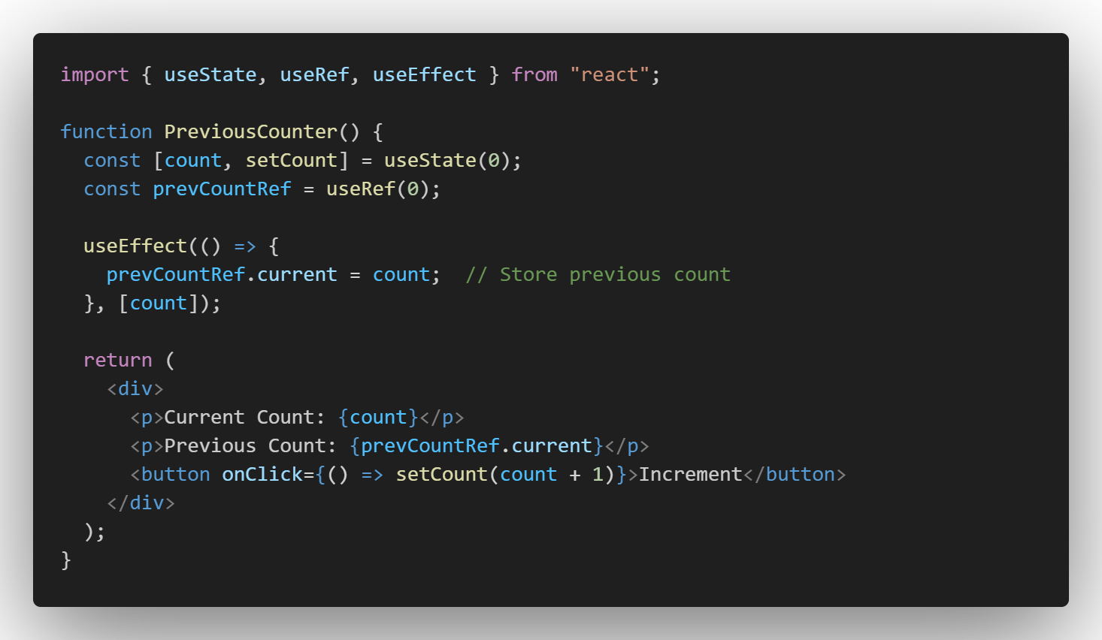

**c) Persisting Values across Re-Rendering** (value of a persist)

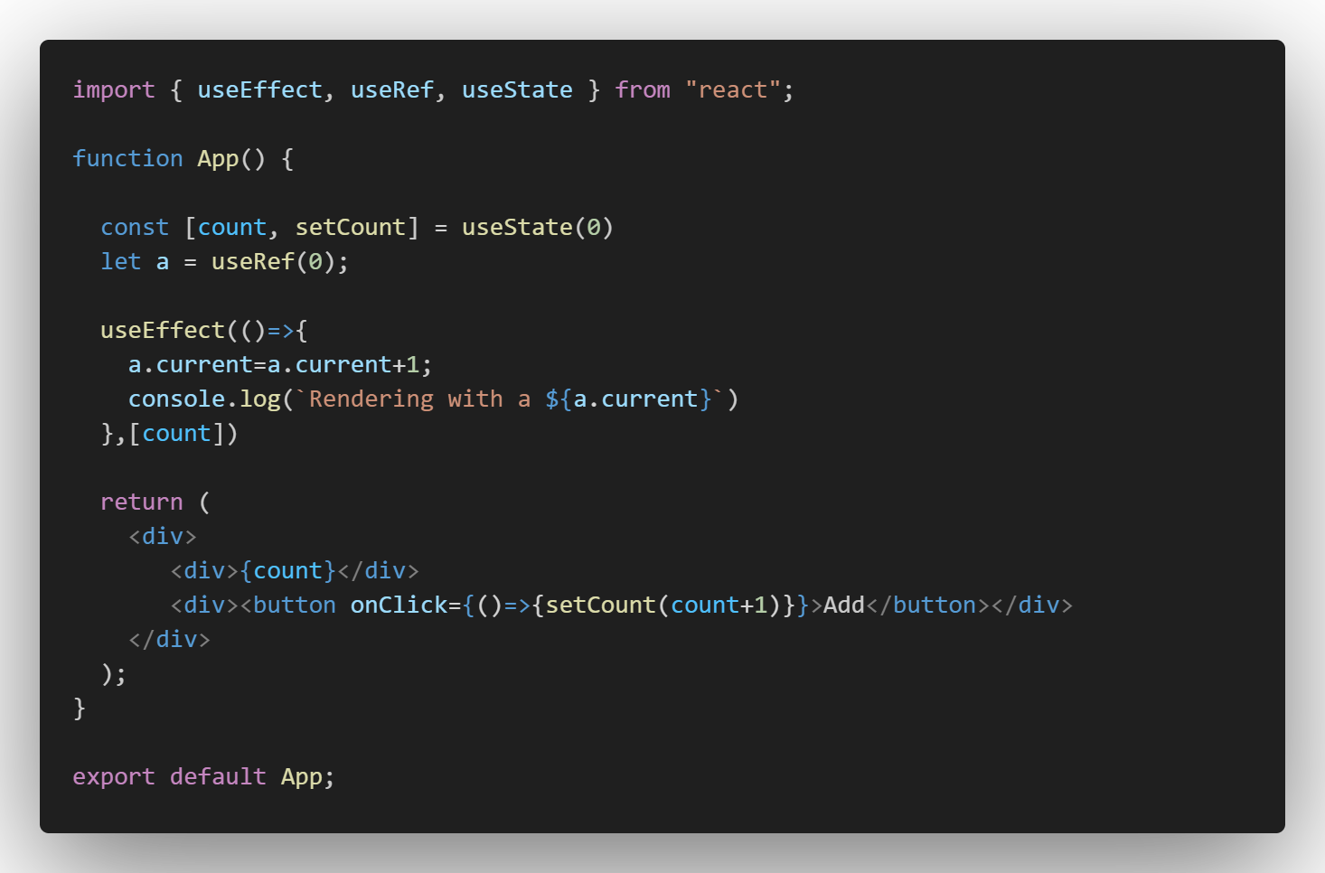

**useRef is useful for managing DOM elements, tracking values across renders, and handling performance optimizations in React!**

**Conditional Rendering & Rendering Lists in React**

**Conditional Rendering**

Conditional rendering in React allows rendering different UI elements based on conditions.

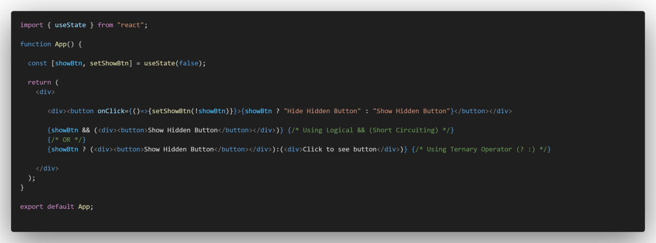

**Rendering Lists** (Displaying Array and Array of Objects**).**

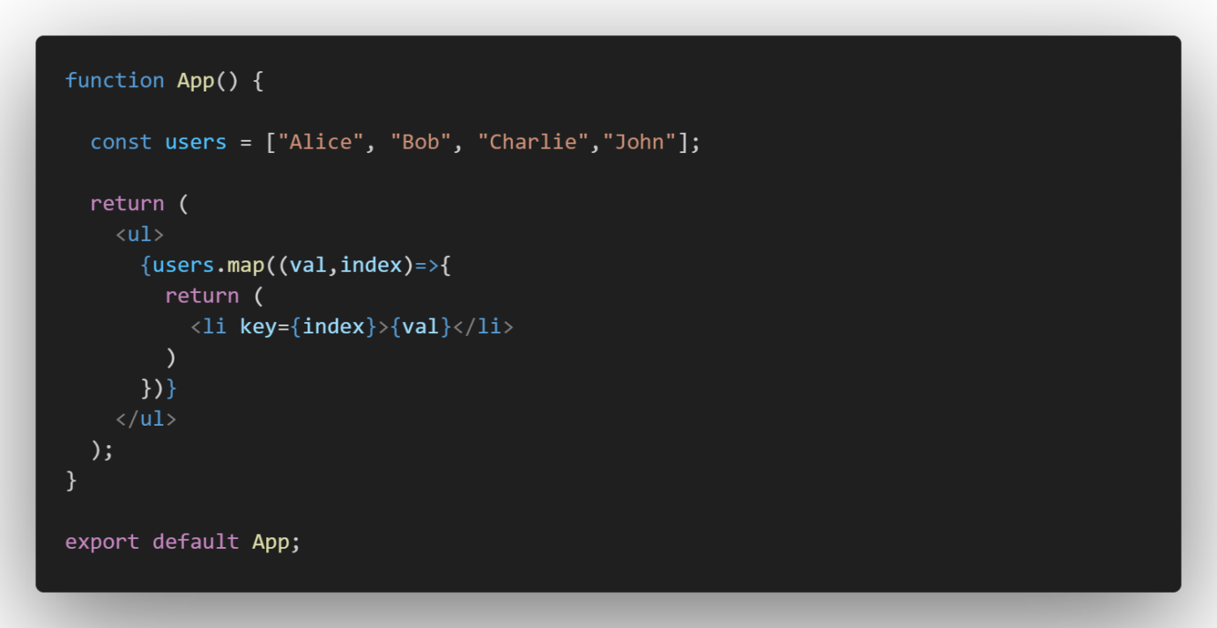

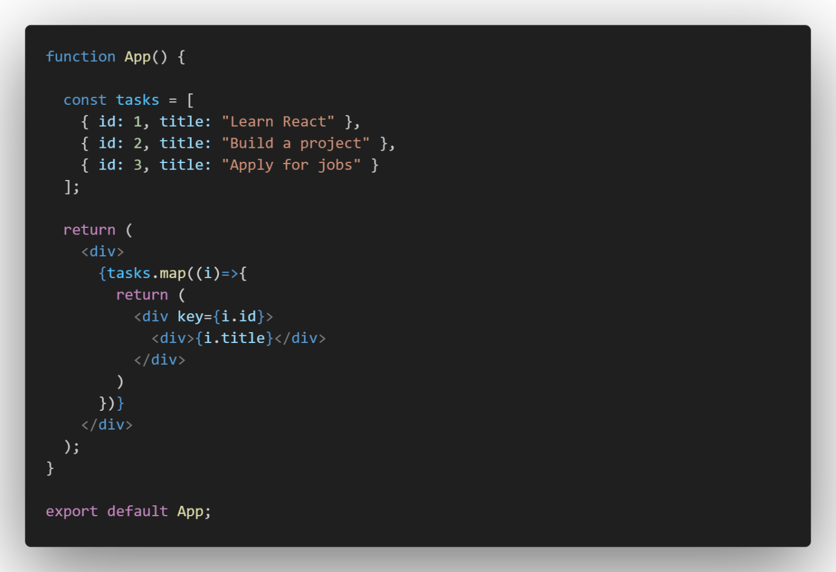

**Handling Events in React**

React handles events similarly to vanilla JavaScript but uses JSX syntax and follows a few key differences.

**1.Adding Event Handlers**

• Events are written in camelCase (onClick, onChange).

• Functions are passed as event handlers instead of strings.

(The function handleClick runs when the button is clicked.)

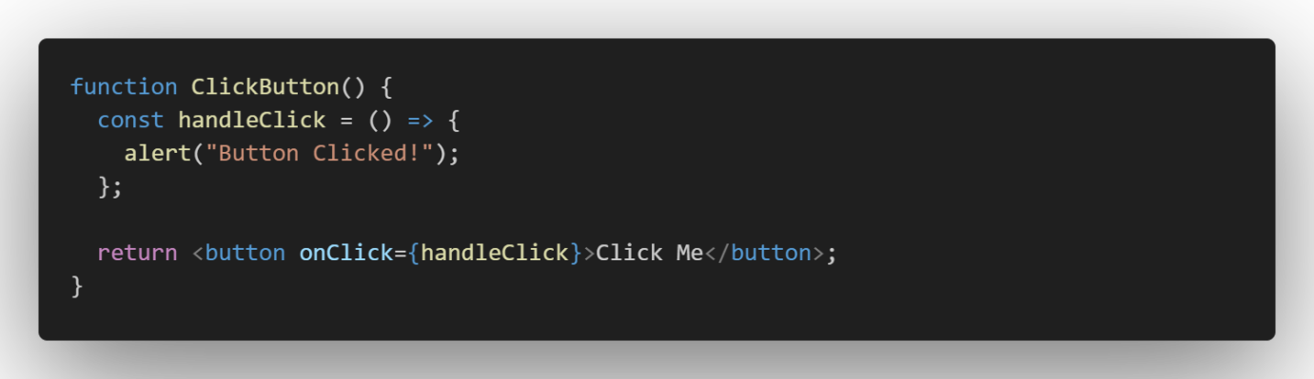

**2. Passing Arguments to Event Handlers** (Using an arrow function inside onClick to pass arguments.)

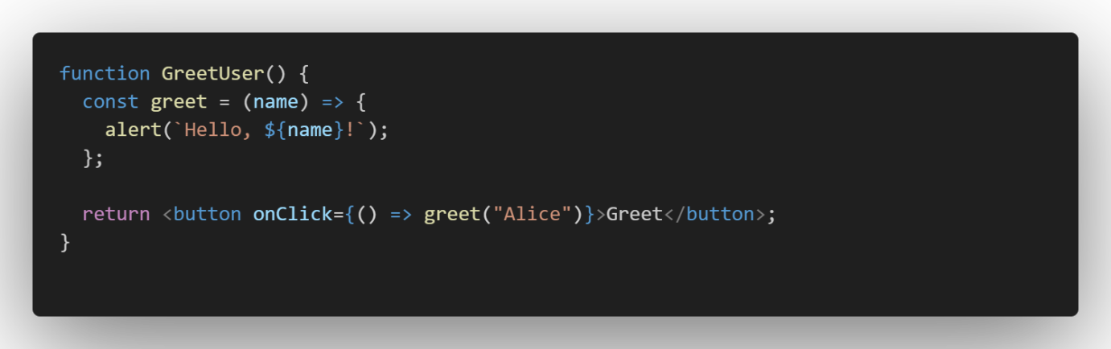

**3. Handling Events in Forms** (Updates state whenever the input value changes.)

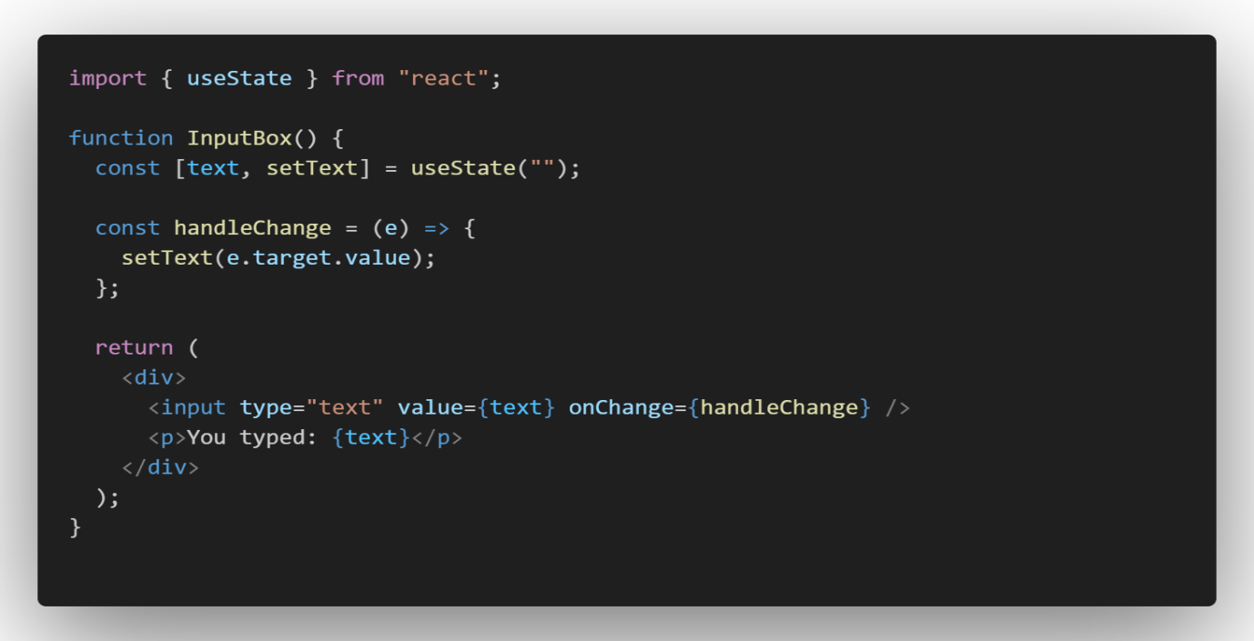

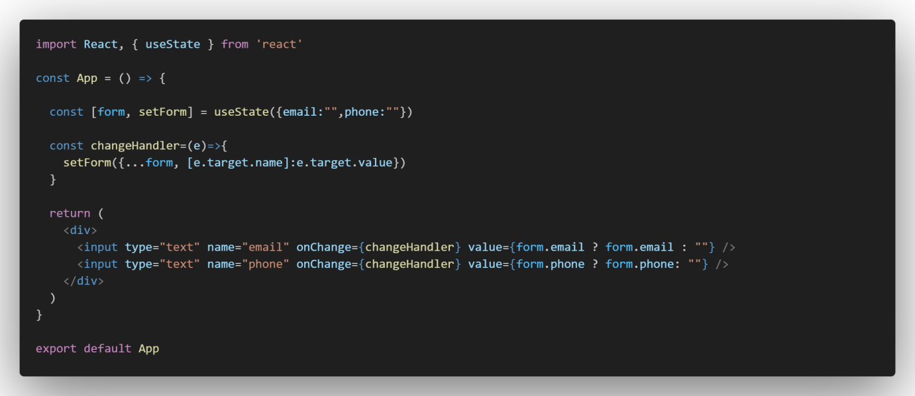

**4. Preventing Default Behavior** (Prevents form from refreshing the page on submission.)

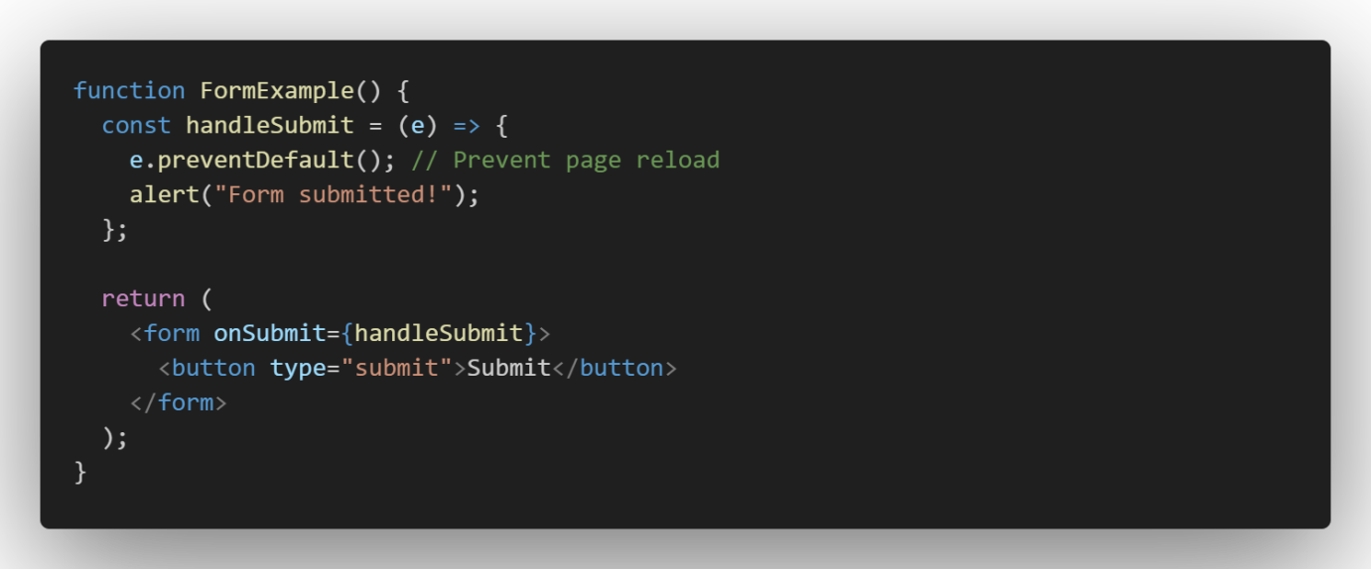

**5. Handling Events in Lists** (Dynamic Events). (Clicking an item displays its name in an alert.)

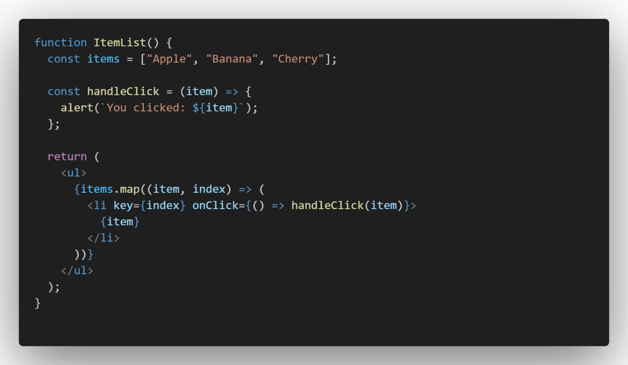

**React efficiently handles user interactions with event handlers, making UI interactive and dynamic!**